UNITED STATES
SECURITIES AND EXCHANGE COMMISSION
Washington, D.C. 20549
______________________________________________________________________
FORM 8-K
______________________________________________________________________
CURRENT REPORT
Pursuant to Section 13 OR 15(d) of The Securities Exchange Act of 1934
Date of Report (Date of earliest event reported): July 13, 2026
______________________________________________________________________
Contineum Therapeutics, Inc.
(Exact name of registrant as specified in its charter)
______________________________________________________________________
Delaware |  |  | 001-42001 |  |  | 27-1467257
(State or other jurisdiction  of incorporation) |  |  | (Commission  File Number) |  |  | (IRS Employer  Identification No.)
3565 General Atomics Court, Suite 200  San Diego, California |  |  | 92121
(Address of principal executive offices) |  |  | (Zip Code)
(858) 333-5280
(Registrant’s telephone number, including area code)
N/A
(Former name or former address, if changed since last report)
______________________________________________________________________
Check the appropriate box below if the Form 8-K filing is intended to simultaneously satisfy the filing obligation of the registrant under any of the following provisions:
☐ |  |  | Written communications pursuant to Rule 425 under the Securities Act (17 CFR 230.425)
☐ |  |  | Soliciting material pursuant to Rule 14a-12 under the Exchange Act (17 CFR 240.14a-12)
☐ |  |  | Pre-commencement communications pursuant to Rule 14d-2(b) under the Exchange Act (17 CFR 240.14d-2(b))
☐ |  |  | Pre-commencement communications pursuant to Rule 13e-4(c) under the Exchange Act (17 CFR 240.13e-4(c))
Securities registered pursuant to Section 12(b) of the Act:
Title of each class |  |  |  |  |  | Trading Symbol(s) |  |  |  |  |  | Name of each exchange on which registered
Class A Common Stock, par value $0.001 per share |  |  |  |  |  | CTNM |  |  |  |  |  | The Nasdaq Global Market LLC  (Nasdaq Global Select Market)
Indicate by check mark whether the registrant is an emerging growth company as defined in Rule 405 of the Securities Act of 1933 (§230.405 of this chapter) or Rule 12b-2 of the Securities Exchange Act of 1934 (§240.12b-2 of this chapter).
Emerging growth company ☒
If an emerging growth company, indicate by check mark if the registrant has elected not to use the extended transition period for complying with any new or revised financial accounting standards provided pursuant to Section 13(a) of the Exchange Act. ☐

Item 7.01 Regulation FD Disclosure.
Corporate Presentation.
On July 13, 2026, the Company updated its corporate presentation to reflect certain business and strategic updates. The updated corporate presentation is attached as Exhibit 99.1 to this report and is incorporated herein by reference. The Company's updated corporate presentation will be posted to the Company’s website, www.contineum-tx.com. The Company plans to use its website to disseminate future updates to its corporate presentation and does not intend to file or furnish a Form 8-K alerting investors each time the presentation is updated.

The information set forth in this Item 7.01 is being furnished pursuant to Item 7.01 and shall not be deemed “filed” for purposes of Section 18 of the Exchange Act of 1934, as amended (the “Exchange Act”), or otherwise subject to the liabilities of that section, and it shall not be deemed incorporated by reference in any filing under the Securities Act of 1933, as amended, or under the Exchange Act, whether made before or after the date hereof, except as expressly provided by specific reference in such a filing.

By filing this Current Report on Form 8-K and furnishing the information in this Item 7.01, the Company makes no admission as to the materiality of Item 7.01 in this report or the presentation available on the Company’s website. The information contained in the corporate presentation is summary information that is intended to be considered in the context of the Company’s filings with the Securities and Exchange Commission (the “SEC”) and other public announcements that the Company makes, by press release or otherwise, from time to time. The Company undertakes no duty or obligation to publicly update or revise the information contained in this Current Report on Form 8-K, although it may do so from time to time as its management believes is appropriate or as required by applicable law. Any such updating may be made through the filing of other reports or documents with the SEC, through press releases, by updating its website or through other public disclosure.

Item 9.01 Financial Statements and Exhibits.
(d) Exhibits.
Exhibit No. |  |  |  |  |  | Description
99.1 |  |  |  |  |  | Corporate Presentation of Contineum Therapeutics, Inc.
104 |  |  |  |  |  | Cover Page Interactive Data File (embedded within the Inline XBRL document).

SIGNATURES
Pursuant to the requirements of the Securities Exchange Act of 1934, as amended, the registrant has duly caused this report to be signed on its behalf by the undersigned hereunto duly authorized.
Date: July 13, 2026
 |  |  | Contineum Therapeutics, Inc.
 |  |  | By: |  |  | /s/ Peter Slover
 |  |  |  |  |  | Peter Slover
Chief Financial Officer
Principal Financial Officer and Principal Accounting Officer
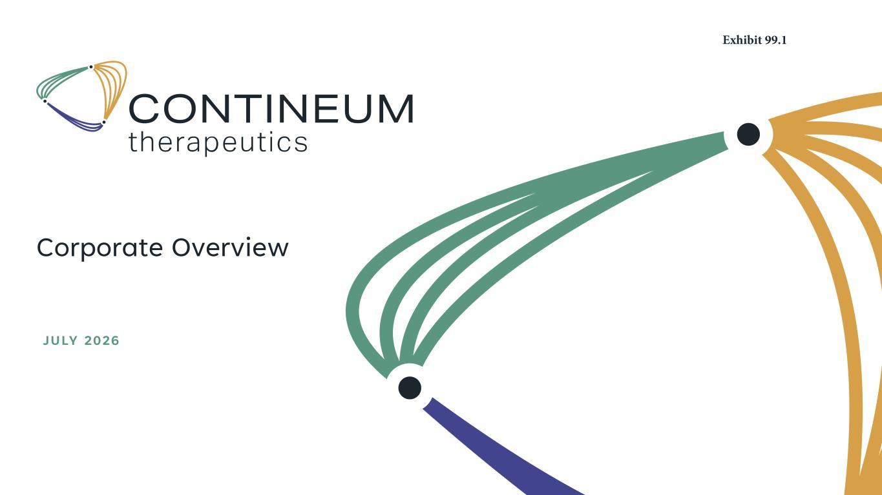

Corporate Overview JULY 2026 Exhibit 99.1

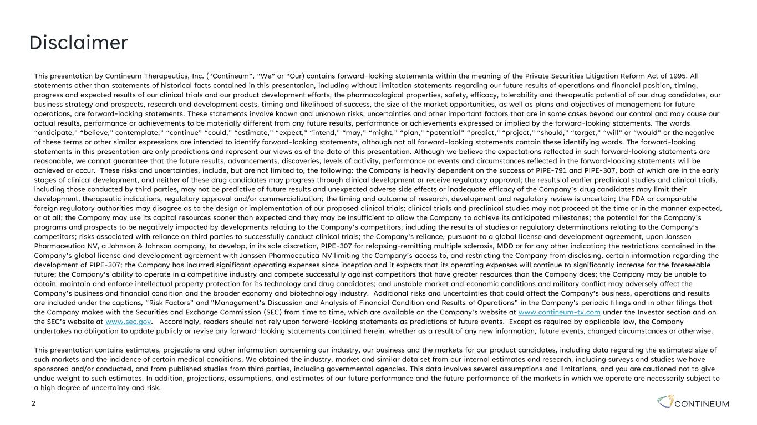
Disclaimer 2 This presentation by Contineum Therapeutics, Inc. (“Contineum”, “We” or “Our) contains forward-looking statements within the meaning of the Private Securities Litigation Reform Act of 1995. All statements other than statements of historical facts contained in this presentation, including without limitation statements regarding our future results of operations and financial position, timing, progress and expected results of our clinical trials and our product development efforts, the pharmacological properties, safety, efficacy, tolerability and therapeutic potential of our drug candidates, our business strategy and prospects, research and development costs, timing and likelihood of success, the size of the market opportunities, as well as plans and objectives of management for future operations, are forward-looking statements. These statements involve known and unknown risks, uncertainties and other important factors that are in some cases beyond our control and may cause our actual results, performance or achievements to be materially different from any future results, performance or achievements expressed or implied by the forward-looking statements. The words “anticipate,” “believe,” contemplate,” “continue” “could,” “estimate,” “expect,” “intend,” “may,” “might,” “plan,” “potential” “predict,” “project,” “should,” “target,” “will” or “would” or the negative of these terms or other similar expressions are intended to identify forward-looking statements, although not all forward-looking statements contain these identifying words. The forward-looking statements in this presentation are only predictions and represent our views as of the date of this presentation. Although we believe the expectations reflected in such forward-looking statements are reasonable, we cannot guarantee that the future results, advancements, discoveries, levels of activity, performance or events and circumstances reflected in the forward-looking statements will be achieved or occur. These risks and uncertainties, include, but are not limited to, the following: the Company is heavily dependent on the success of PIPE-791 and PIPE-307, both of which are in the early stages of clinical development, and neither of these drug candidates may progress through clinical development or receive regulatory approval; the results of earlier preclinical studies and clinical trials, including those conducted by third parties, may not be predictive of future results and unexpected adverse side effects or inadequate efficacy of the Company’s drug candidates may limit their development, therapeutic indications, regulatory approval and/or commercialization; the timing and outcome of research, development and regulatory review is uncertain; the FDA or comparable foreign regulatory authorities may disagree as to the design or implementation of our proposed clinical trials; clinical trials and preclinical studies may not proceed at the time or in the manner expected, or at all; the Company may use its capital resources sooner than expected and they may be insufficient to allow the Company to achieve its anticipated milestones; the potential for the Company’s programs and prospects to be negatively impacted by developments relating to the Company’s competitors, including the results of studies or regulatory determinations relating to the Company’s competitors; risks associated with reliance on third parties to successfully conduct clinical trials; the Company’s reliance, pursuant to a global license and development agreement, upon Janssen Pharmaceutica NV, a Johnson & Johnson company, to develop, in its sole discretion, PIPE-307 for relapsing-remitting multiple sclerosis, MDD or for any other indication; the restrictions contained in the Company’s global license and development agreement with Janssen Pharmaceutica NV limiting the Company’s access to, and restricting the Company from disclosing, certain information regarding the development of PIPE-307; the Company has incurred significant operating expenses since inception and it expects that its operating expenses will continue to significantly increase for the foreseeable future; the Company’s ability to operate in a competitive industry and compete successfully against competitors that have greater resources than the Company does; the Company may be unable to obtain, maintain and enforce intellectual property protection for its technology and drug candidates; and unstable market and economic conditions and military conflict may adversely affect the Company’s business and financial condition and the broader economy and biotechnology industry. Additional risks and uncertainties that could affect the Company’s business, operations and results are included under the captions, “Risk Factors” and "Management’s Discussion and Analysis of Financial Condition and Results of Operations” in the Company's periodic filings and in other filings that the Company makes with the Securities and Exchange Commission (SEC) from time to time, which are available on the Company’s website at www.contineum-tx.com under the Investor section and on the SEC’s website at www.sec.gov. Accordingly, readers should not rely upon forward-looking statements as predictions of future events. Except as required by applicable law, the Company undertakes no obligation to update publicly or revise any forward-looking statements contained herein, whether as a result of any new information, future events, changed circumstances or otherwise. This presentation contains estimates, projections and other information concerning our industry, our business and the markets for our product candidates, including data regarding the estimated size of such markets and the incidence of certain medical conditions. We obtained the industry, market and similar data set from our internal estimates and research, including surveys and studies we have sponsored and/or conducted, and from published studies from third parties, including governmental agencies. This data involves several assumptions and limitations, and you are cautioned not to give undue weight to such estimates. In addition, projections, assumptions, and estimates of our future performance and the future performance of the markets in which we operate are necessarily subject to a high degree of uncertainty and risk.

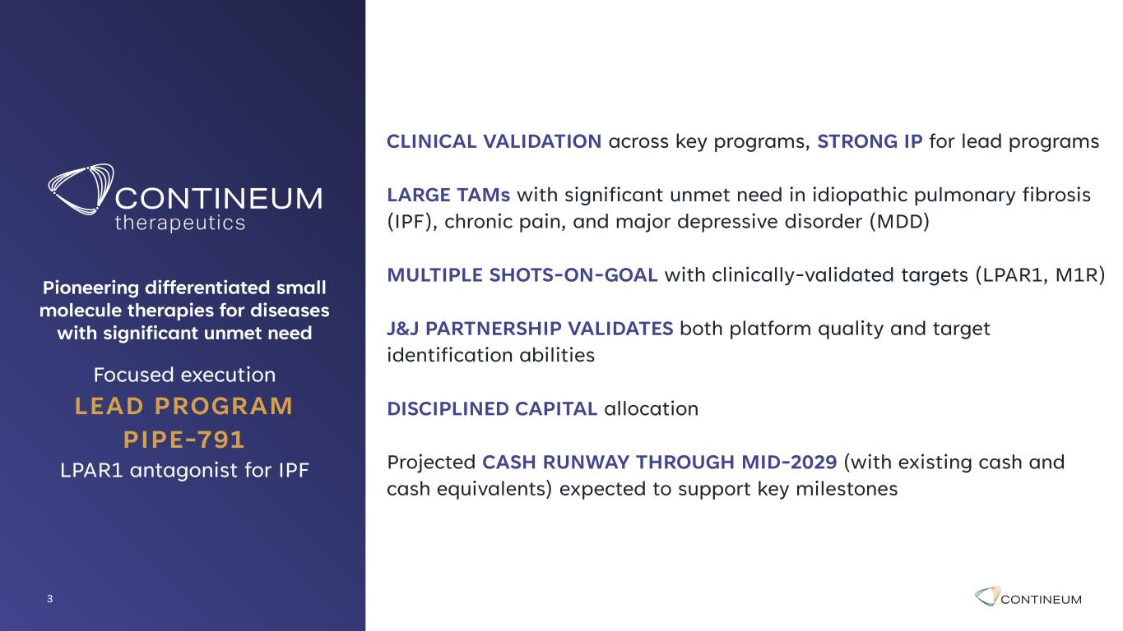
3 Pioneering differentiated small molecule therapies for diseases with significant unmet need Focused execution LEAD PROGRAM PIPE-791 LPAR1 antagonist for IPF CLINICAL VALIDATION across key programs, STRONG IP for lead programs LARGE TAMs with significant unmet need in idiopathic pulmonary fibrosis (IPF), chronic pain, and major depressive disorder (MDD) MULTIPLE SHOTS-ON-GOAL with clinically-validated targets (LPAR1, M1R) J&J PARTNERSHIP VALIDATES both platform quality and target identification abilities DISCIPLINED CAPITAL allocation Projected CASH RUNWAY THROUGH MID-2029 (with existing cash and cash equivalents) expected to support key milestones

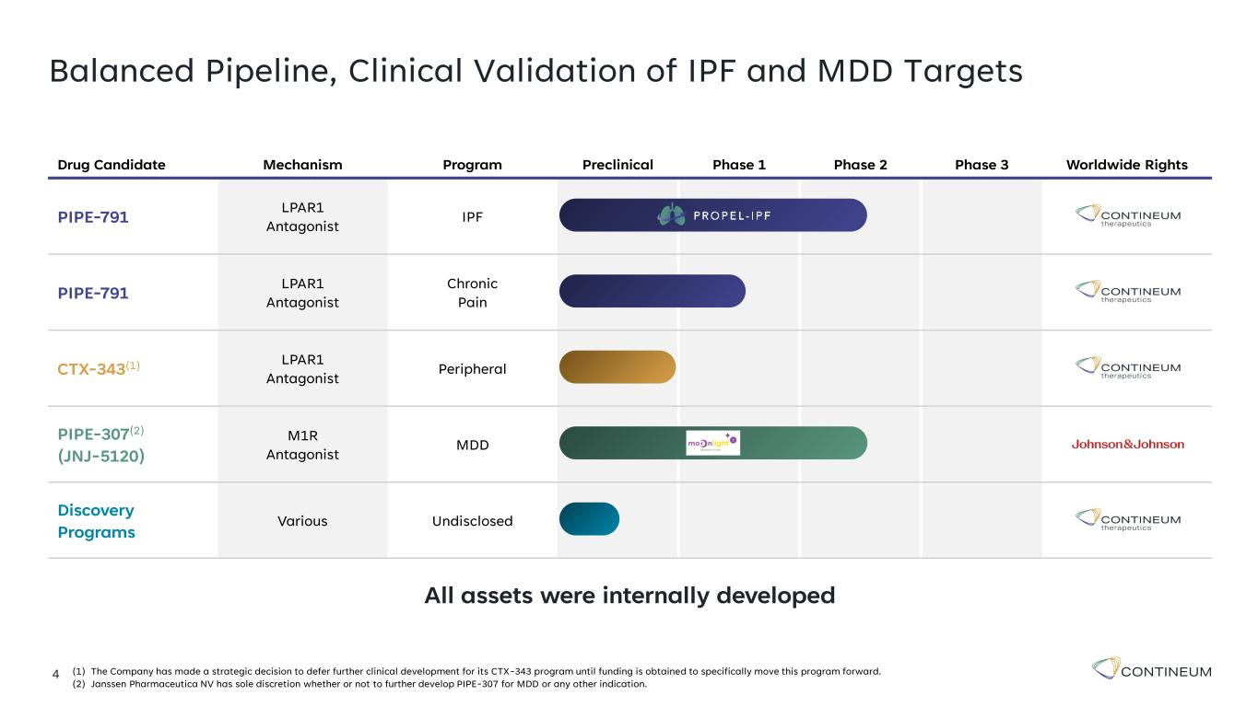
4 Balanced Pipeline, Clinical Validation of IPF and MDD Targets Drug Candidate Mechanism Program Preclinical Phase 1 Phase 2 Phase 3 Worldwide Rights PIPE-791 LPAR1 Antagonist IPF PIPE-791 LPAR1 Antagonist Chronic Pain CTX-343(1) LPAR1 Antagonist Peripheral PIPE-307(2) (JNJ-5120) M1R Antagonist MDD Discovery Programs Various Undisclosed (1) The Company has made a strategic decision to defer further clinical development for its CTX-343 program until funding is obtained to specifically move this program forward. (2) Janssen Pharmaceutica NV has sole discretion whether or not to further develop PIPE-307 for MDD or any other indication. All assets were internally developed

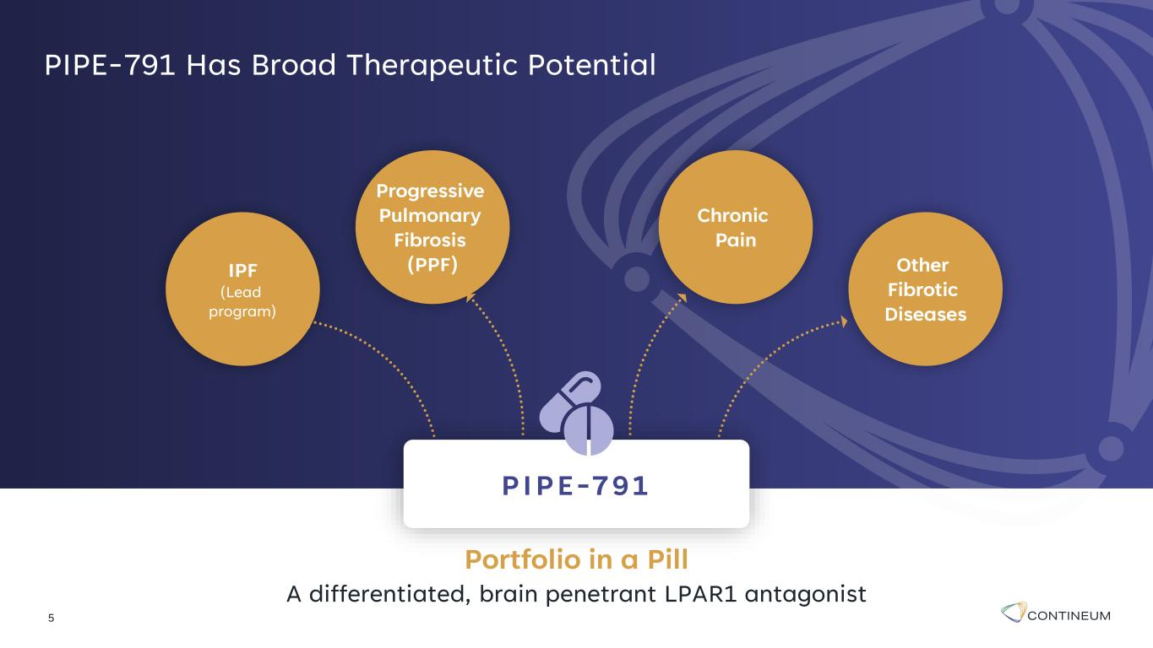
5 PIPE-791 Has Broad Therapeutic Potential Other Fibrotic Diseases Chronic Pain IPF (Lead program) Progressive Pulmonary Fibrosis (PPF) Portfolio in a Pill A differentiated, brain penetrant LPAR1 antagonist PIPE-791

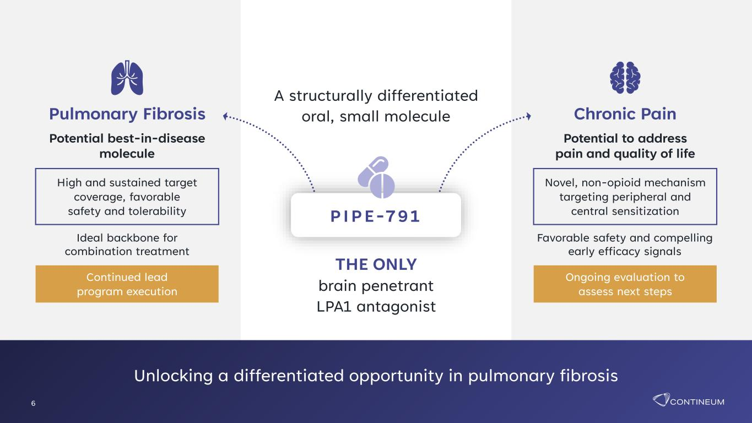
THE ONLY brain penetrant LPA1 antagonist A structurally differentiated oral, small molecule Chronic Pain Potential to address pain and quality of life Novel, non-opioid mechanism targeting peripheral and central sensitization Favorable safety and compelling early efficacy signals Ongoing evaluation to assess next steps Pulmonary Fibrosis Potential best-in-disease molecule High and sustained target coverage, favorable safety and tolerability Ideal backbone for combination treatment Continued lead program execution Unlocking a differentiated opportunity in pulmonary fibrosis 6 PIPE-791

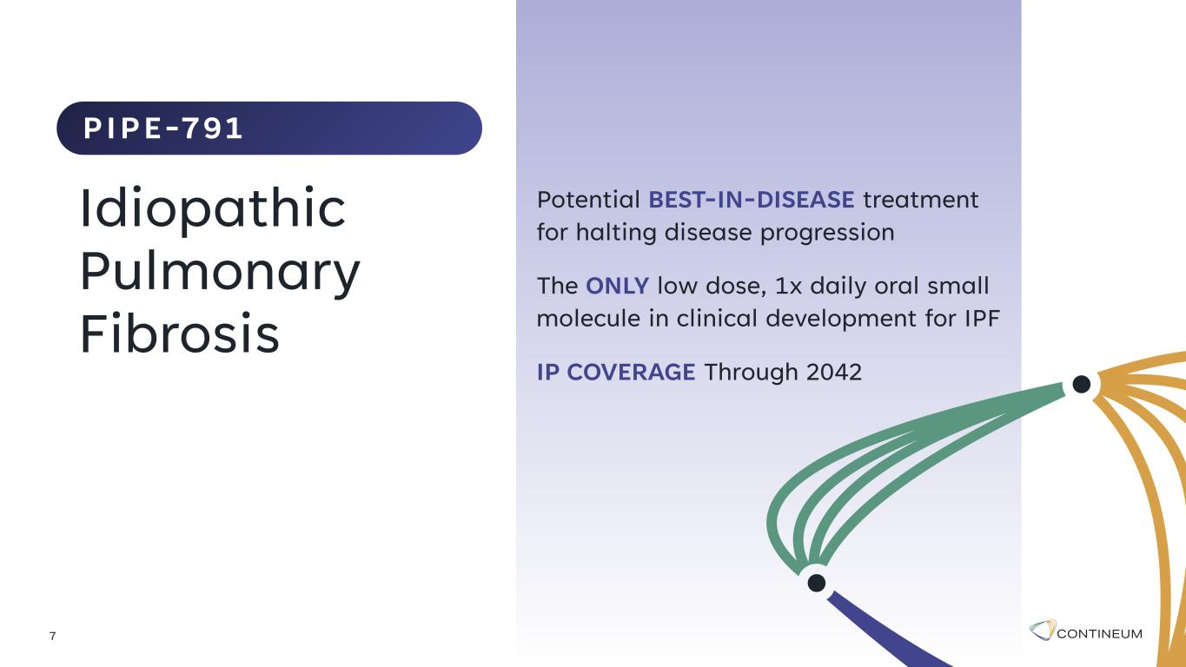
Potential BEST-IN-DISEASE treatment for halting disease progression The ONLY low dose, 1x daily oral small molecule in clinical development for IPF IP COVERAGE Through 2042 7 Idiopathic Pulmonary Fibrosis PIPE-791

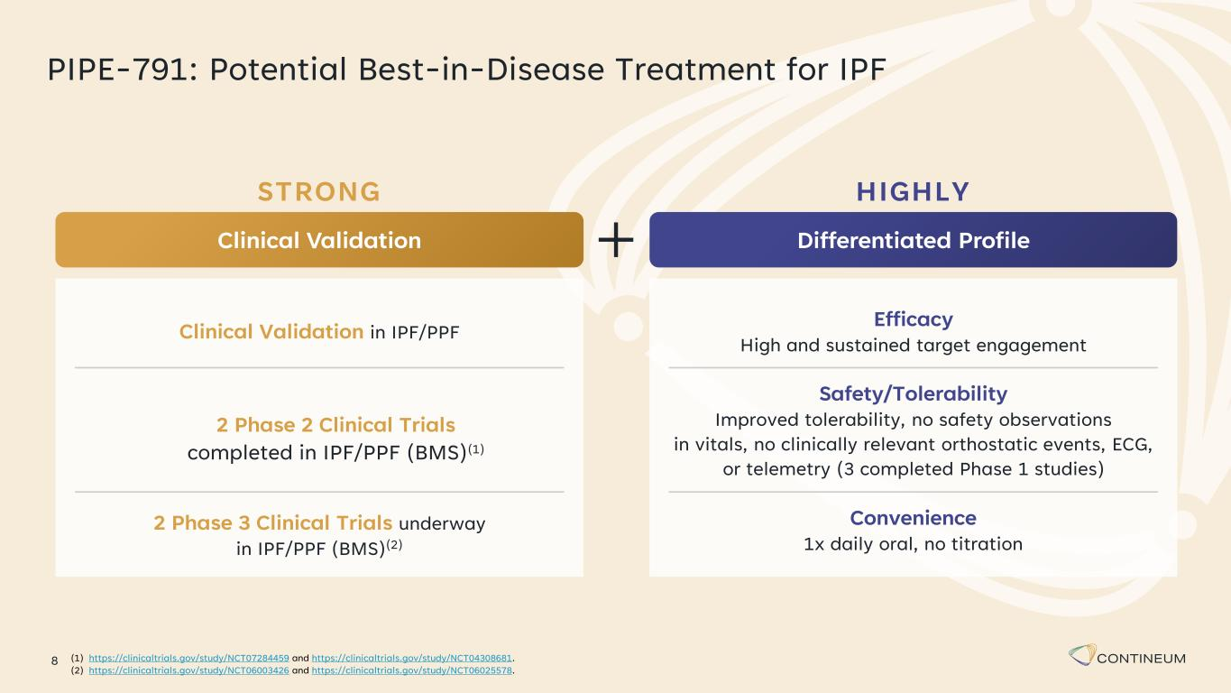
8 PIPE-791: Potential Best-in-Disease Treatment for IPF HIGHLY Differentiated Profile Efficacy High and sustained target engagement Safety/Tolerability Improved tolerability, no safety observations in vitals, no clinically relevant orthostatic events, ECG, or telemetry (3 completed Phase 1 studies) Convenience 1x daily oral, no titration STRONG Clinical Validation Clinical Validation in IPF/PPF 2 Phase 3 Clinical Trials underway in IPF/PPF (BMS)(2) 2 Phase 2 Clinical Trials completed in IPF/PPF (BMS)(1) (1) https://clinicaltrials.gov/study/NCT07284459 and https://clinicaltrials.gov/study/NCT04308681. (2) https://clinicaltrials.gov/study/NCT06003426 and https://clinicaltrials.gov/study/NCT06025578.

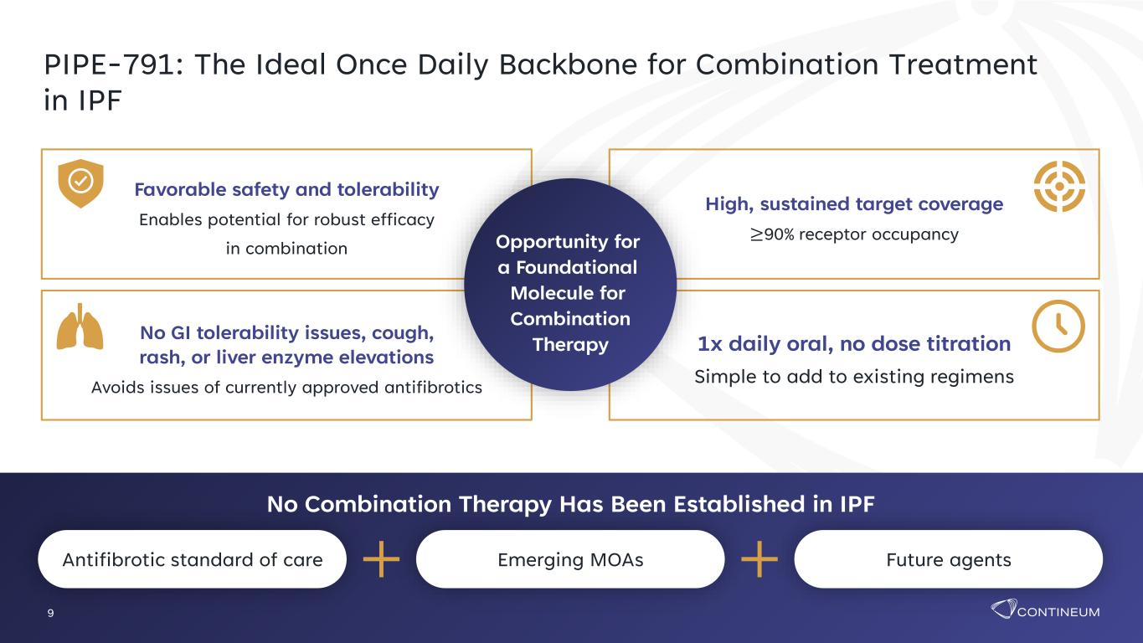
9 PIPE-791: The Ideal Once Daily Backbone for Combination Treatment in IPF Emerging MOAsAntifibrotic standard of care Future agents No Combination Therapy Has Been Established in IPF Favorable safety and tolerability Enables potential for robust efficacy in combination No GI tolerability issues, cough, rash, or liver enzyme elevations Avoids issues of currently approved antifibrotics High, sustained target coverage ≥90% receptor occupancy 1x daily oral, no dose titration Simple to add to existing regimens Opportunity for a Foundational Molecule for Combination Therapy

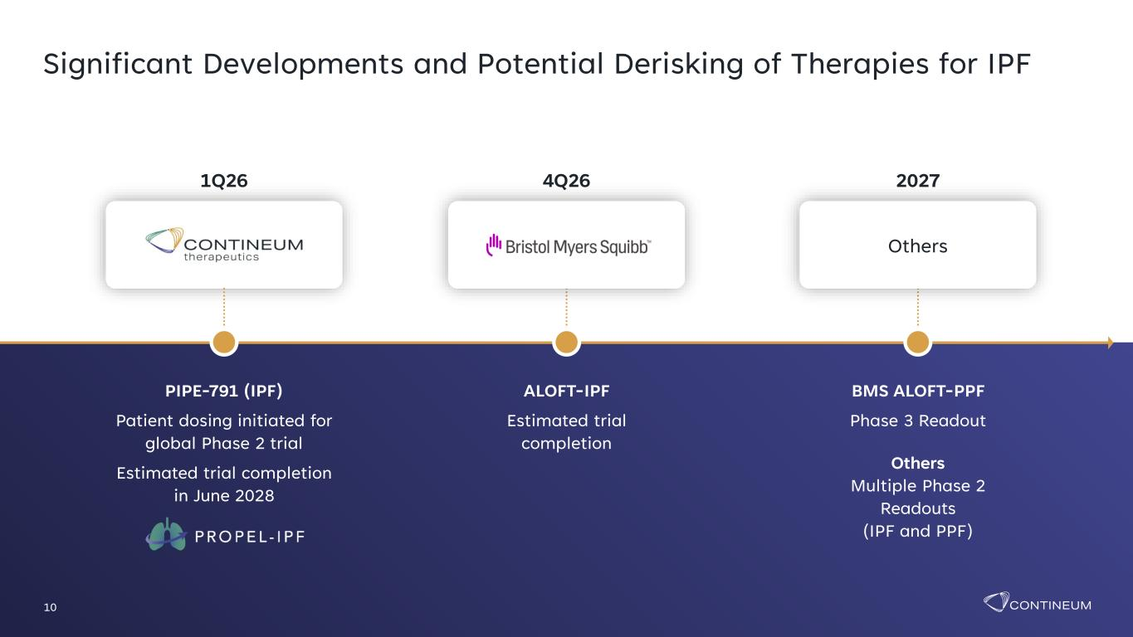
10 Significant Developments and Potential Derisking of Therapies for IPF BMS ALOFT-PPF Phase 3 Readout Others Multiple Phase 2 Readouts (IPF and PPF) 2027 Others ALOFT-IPF Estimated trial completion 4Q26 PIPE-791 (IPF) Patient dosing initiated for global Phase 2 trial Estimated trial completion in June 2028 1Q26

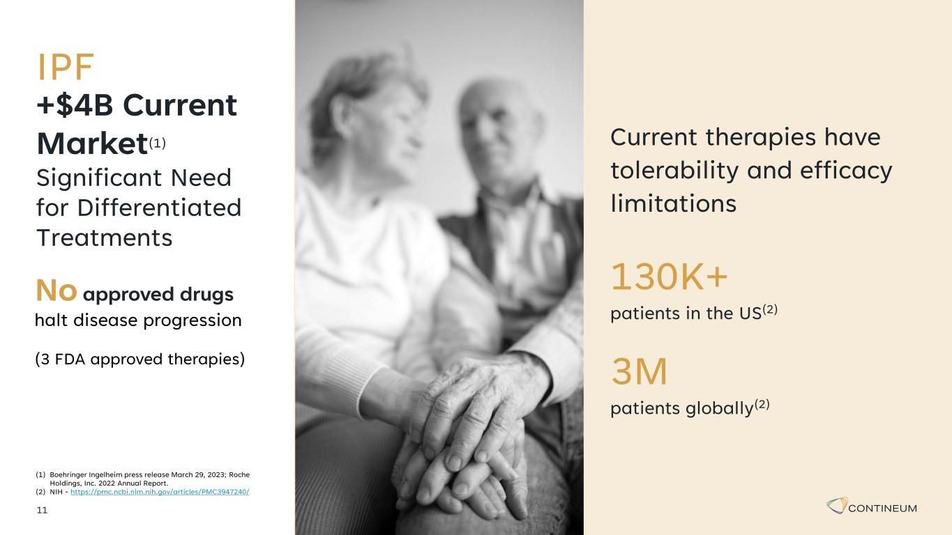
11 +$4B Current Market(1) Significant Need for Differentiated Treatments (1) Boehringer Ingelheim press release March 29, 2023; Roche Holdings, Inc. 2022 Annual Report. (2) NIH - https://pmc.ncbi.nlm.nih.gov/articles/PMC3947240/ Current therapies have tolerability and efficacy limitations No approved drugs halt disease progression (3 FDA approved therapies) 130K+ patients in the US(2) 3M patients globally(2) IPF

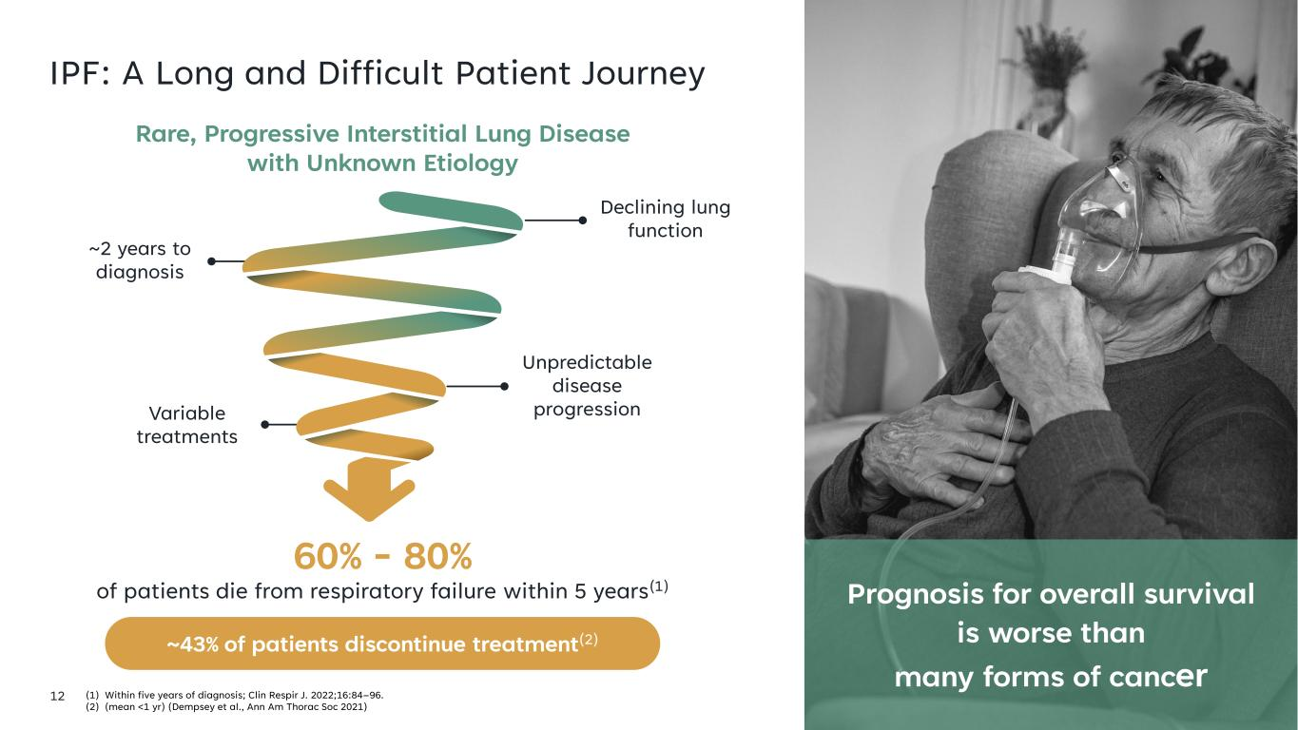
12 IPF: A Long and Difficult Patient Journey (1) Within five years of diagnosis; Clin Respir J. 2022;16:84–96. (2) (mean <1 yr) (Dempsey et al., Ann Am Thorac Soc 2021) Prognosis for overall survival is worse than many forms of cancer Rare, Progressive Interstitial Lung Disease with Unknown Etiology 60% - 80% of patients die from respiratory failure within 5 years(1) Declining lung function Unpredictable disease progressionVariable treatments ~2 years to diagnosis ~43% of patients discontinue treatment(2)

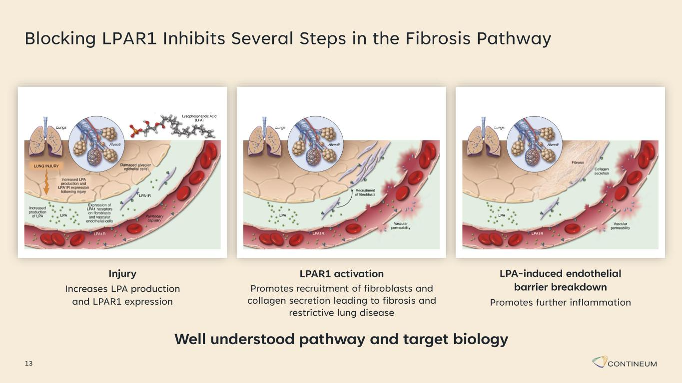
Blocking LPAR1 Inhibits Several Steps in the Fibrosis Pathway 13 Injury Increases LPA production and LPAR1 expression LPAR1 activation Promotes recruitment of fibroblasts and collagen secretion leading to fibrosis and restrictive lung disease LPA-induced endothelial barrier breakdown Promotes further inflammation Well understood pathway and target biology

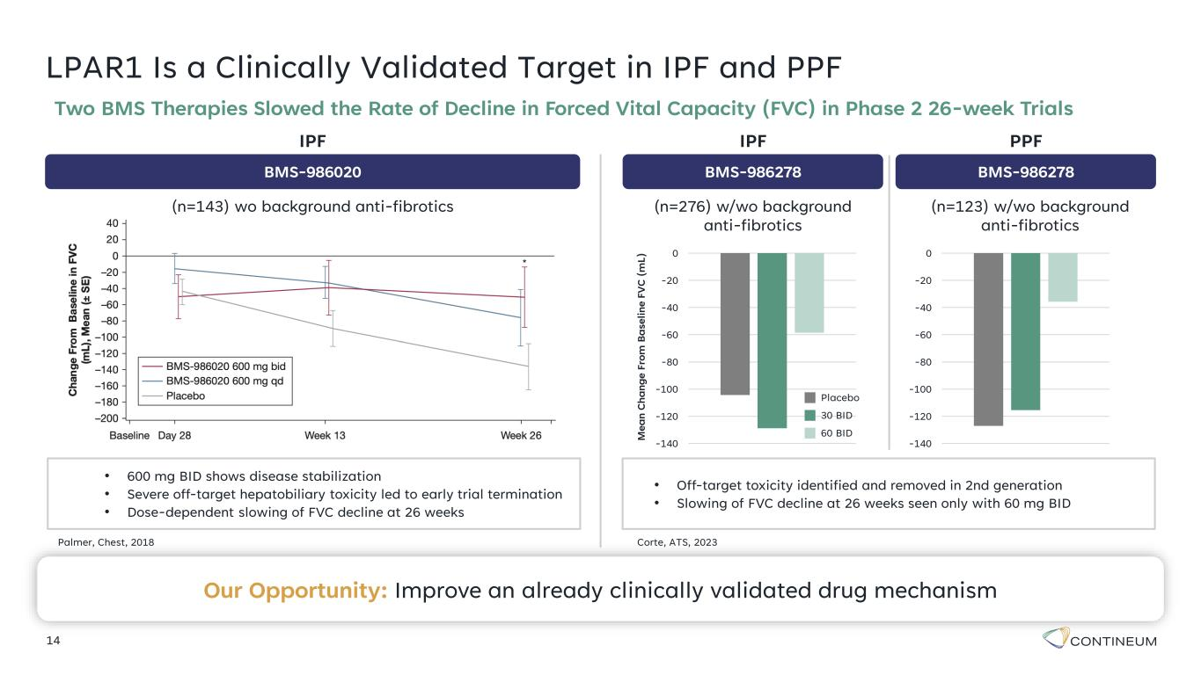
LPAR1 Is a Clinically Validated Target in IPF and PPF 14 Two BMS Therapies Slowed the Rate of Decline in Forced Vital Capacity (FVC) in Phase 2 26-week Trials • 600 mg BID shows disease stabilization • Severe off-target hepatobiliary toxicity led to early trial termination • Dose-dependent slowing of FVC decline at 26 weeks Palmer, Chest, 2018 • Off-target toxicity identified and removed in 2nd generation • Slowing of FVC decline at 26 weeks seen only with 60 mg BID -140 -120 -100 -80 -60 -40 -20 0 Corte, ATS, 2023 M e a n C h a n g e F ro m B a se li n e F V C ( m L ) -140 -120 -100 -80 -60 -40 -20 0 BMS-986020 (n=143) wo background anti-fibrotics IPF BMS-986278 (n=276) w/wo background anti-fibrotics IPF BMS-986278 (n=123) w/wo background anti-fibrotics PPF Placebo 30 BID 60 BID Our Opportunity: Improve an already clinically validated drug mechanism

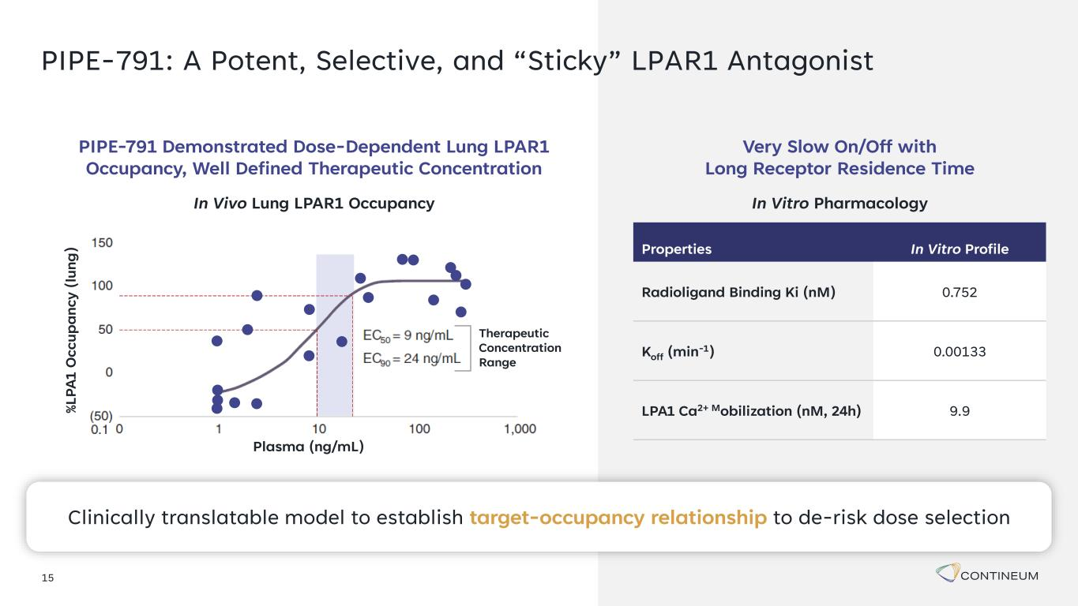
15 PIPE-791: A Potent, Selective, and “Sticky” LPAR1 Antagonist Properties In Vitro Profile Radioligand Binding Ki (nM) 0.752 Koff (min-1) 0.00133 LPA1 Ca2+ Mobilization (nM, 24h) 9.9 In Vitro Pharmacology Very Slow On/Off with Long Receptor Residence Time % L P A 1 O c c u p a n c y ( lu n g ) Plasma (ng/mL) Therapeutic Concentration Range In Vivo Lung LPAR1 Occupancy PIPE-791 Demonstrated Dose-Dependent Lung LPAR1 Occupancy, Well Defined Therapeutic Concentration Clinically translatable model to establish target-occupancy relationship to de-risk dose selection

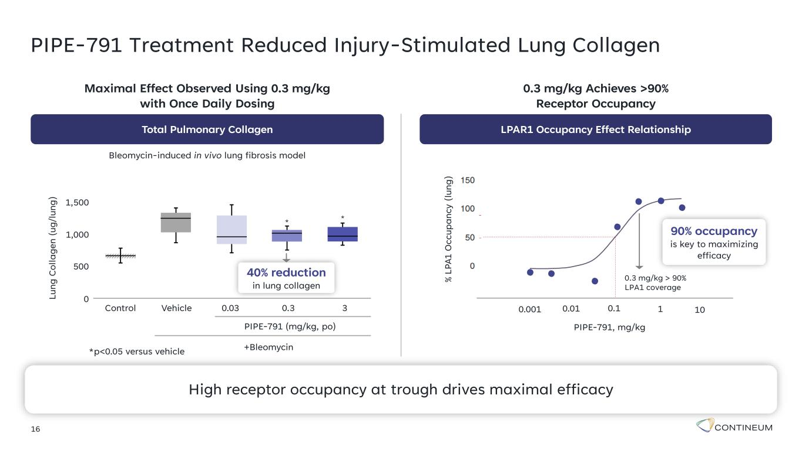
16 PIPE-791 Treatment Reduced Injury-Stimulated Lung Collagen *p<0.05 versus vehicle L u n g C o ll a g e n ( u g /l u n g ) 1,500 1,000 500 0 Control Vehicle 0.03 0.3 3 PIPE-791 (mg/kg, po) +Bleomycin * * Total Pulmonary Collagen Maximal Effect Observed Using 0.3 mg/kg with Once Daily Dosing Bleomycin-induced in vivo lung fibrosis model LPAR1 Occupancy Effect Relationship 0.3 mg/kg Achieves >90% Receptor Occupancy PIPE-791, mg/kg 0.10.001 100.01 1 0.3 mg/kg > 90% LPA1 coverage % L P A 1 O c c u p a n c y ( lu n g ) 90% occupancy is key to maximizing efficacy 40% reduction in lung collagen High receptor occupancy at trough drives maximal efficacy

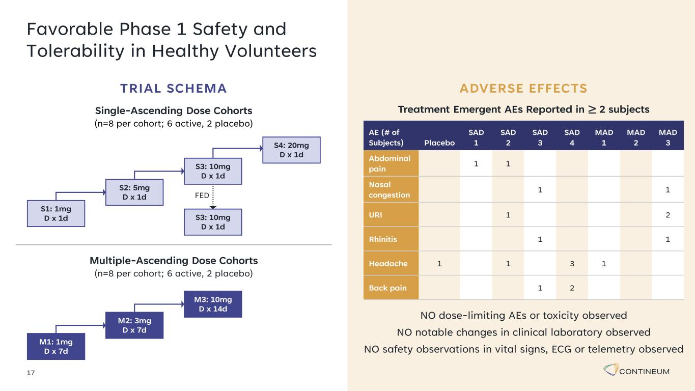
17 Favorable Phase 1 Safety and Tolerability in Healthy Volunteers M1: 1mg D x 7d M2: 3mg D x 7d M3: 10mg D x 14d NO dose-limiting AEs or toxicity observed NO notable changes in clinical laboratory observed NO safety observations in vital signs, ECG or telemetry observed Treatment Emergent AEs Reported in ≥ 2 subjects AE (# of Subjects) Placebo SAD 1 SAD 2 SAD 3 SAD 4 MAD 1 MAD 2 MAD 3 Abdominal pain 1 1 Nasal congestion 1 1 URI 1 2 Rhinitis 1 1 Headache 1 1 3 1 Back pain 1 2 ADVERSE EFFECTS Multiple-Ascending Dose Cohorts (n=8 per cohort; 6 active, 2 placebo) Single-Ascending Dose Cohorts (n=8 per cohort; 6 active, 2 placebo) S4: 20mg D x 1d S3: 10mg D x 1d FED S1: 1mg D x 1d S2: 5mg D x 1d S3: 10mg D x 1d TRIAL SCHEMA

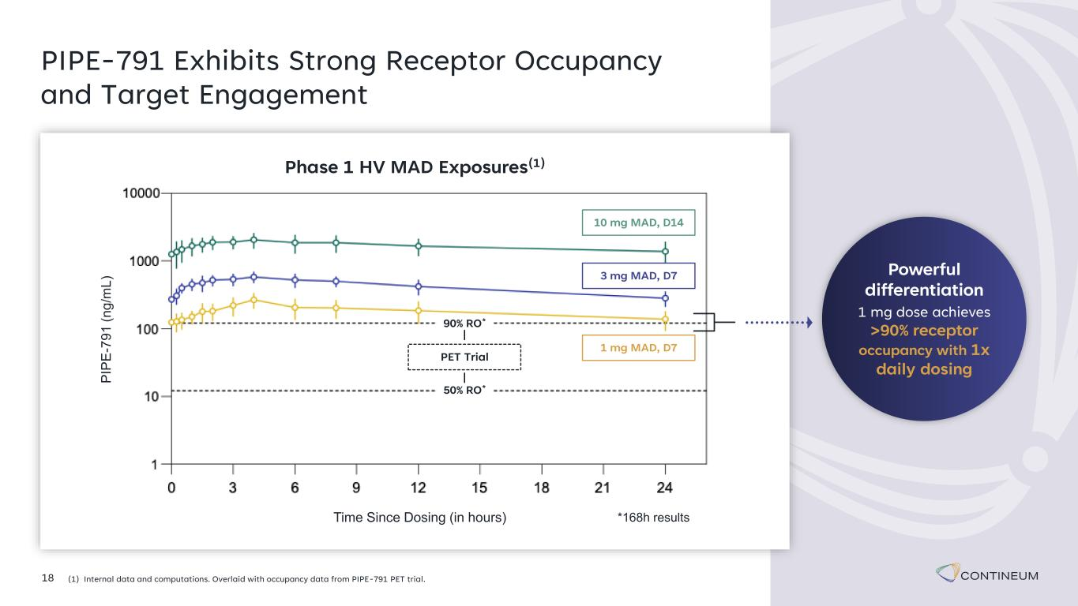
18 PIPE-791 Exhibits Strong Receptor Occupancy and Target Engagement (1) Internal data and computations. Overlaid with occupancy data from PIPE-791 PET trial. Phase 1 HV MAD Exposures(1) *168h resultsTime Since Dosing (in hours) P IP E -7 9 1 ( n g /m L ) 3 mg MAD, D7 10 mg MAD, D14 1 mg MAD, D7 50% RO* 90% RO* PET Trial Powerful differentiation 1 mg dose achieves >90% receptor occupancy with 1x daily dosing

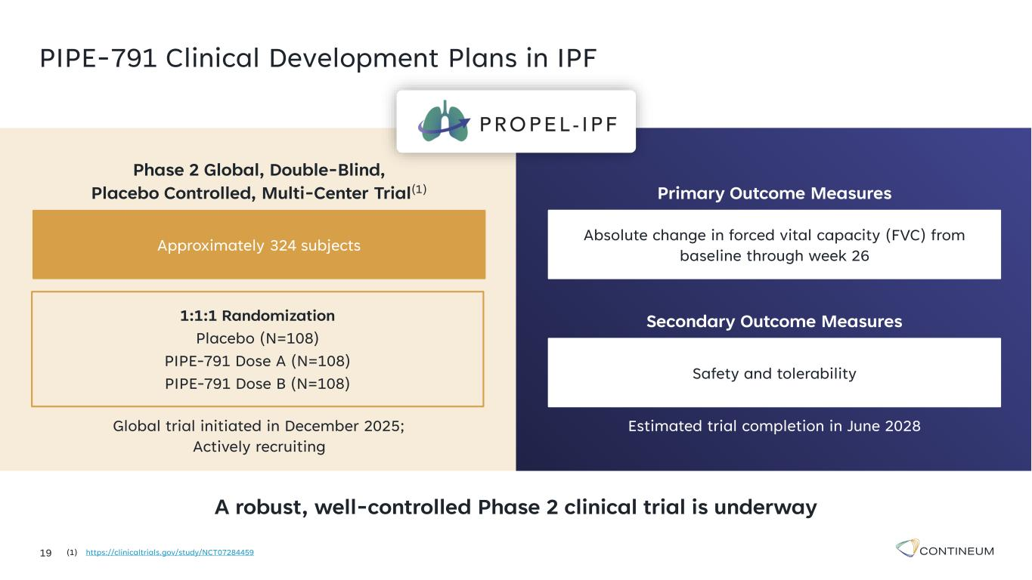
A robust, well-controlled Phase 2 clinical trial is underway 19 PIPE-791 Clinical Development Plans in IPF (1) https://clinicaltrials.gov/study/NCT07284459 Primary Outcome Measures Absolute change in forced vital capacity (FVC) from baseline through week 26 Secondary Outcome Measures Safety and tolerability Estimated trial completion in June 2028 Phase 2 Global, Double-Blind, Placebo Controlled, Multi-Center Trial(1) Approximately 324 subjects Global trial initiated in December 2025; Actively recruiting 1:1:1 Randomization Placebo (N=108) PIPE-791 Dose A (N=108) PIPE-791 Dose B (N=108)

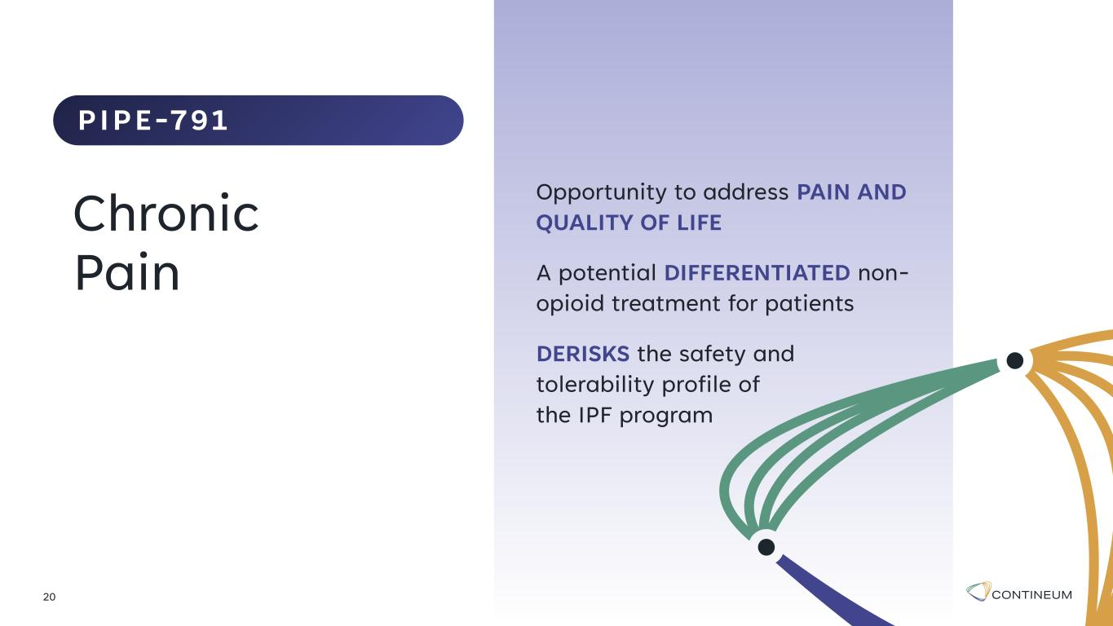
Opportunity to address PAIN AND QUALITY OF LIFE A potential DIFFERENTIATED non- opioid treatment for patients DERISKS the safety and tolerability profile of the IPF program 20 Chronic Pain PIPE-791

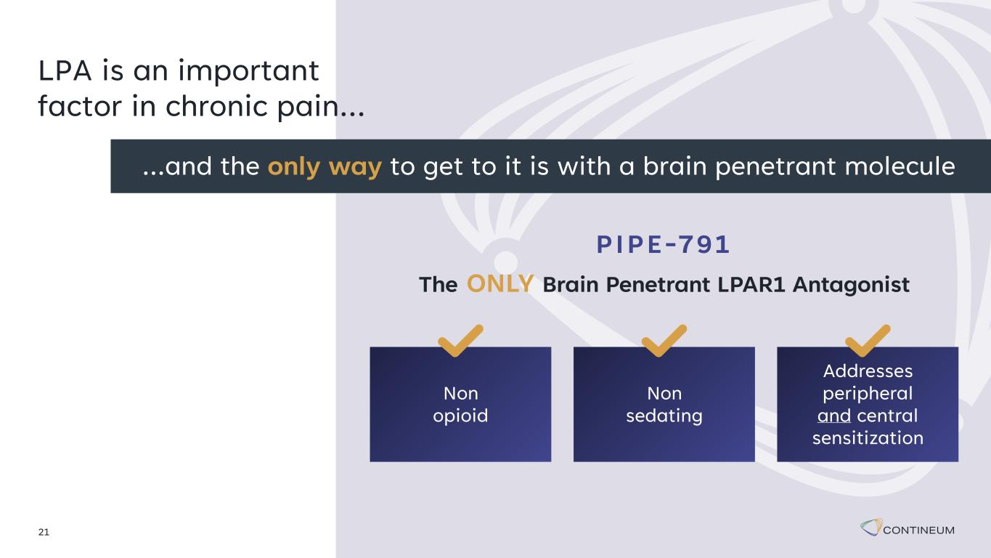
21 LPA is an important factor in chronic pain… …and the only way to get to it is with a brain penetrant molecule PIPE-791 The ONLY Brain Penetrant LPAR1 Antagonist Non opioid Non sedating Addresses peripheral and central sensitization

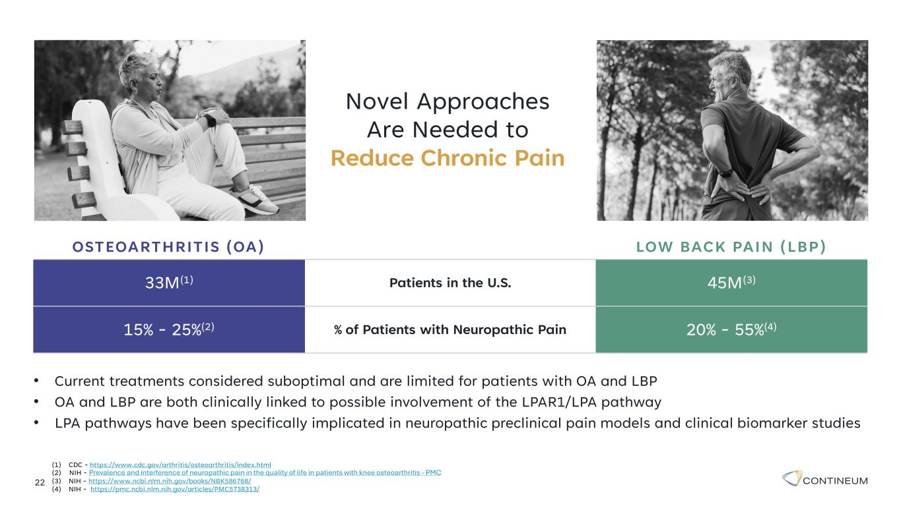
22 Novel Approaches Are Needed to Reduce Chronic Pain (1) CDC - https://www.cdc.gov/arthritis/osteoarthritis/index.html (2) NIH - Prevalence and interference of neuropathic pain in the quality of life in patients with knee osteoarthritis - PMC (3) NIH - https://www.ncbi.nlm.nih.gov/books/NBK586768/ (4) NIH - https://pmc.ncbi.nlm.nih.gov/articles/PMC5738313/ • Current treatments considered suboptimal and are limited for patients with OA and LBP • OA and LBP are both clinically linked to possible involvement of the LPAR1/LPA pathway • LPA pathways have been specifically implicated in neuropathic preclinical pain models and clinical biomarker studies OSTEOARTHRITIS (OA) LOW BACK PAIN (LBP) 33M(1) Patients in the U.S. 45M(3) 15% - 25%(2) % of Patients with Neuropathic Pain 20% - 55%(4)

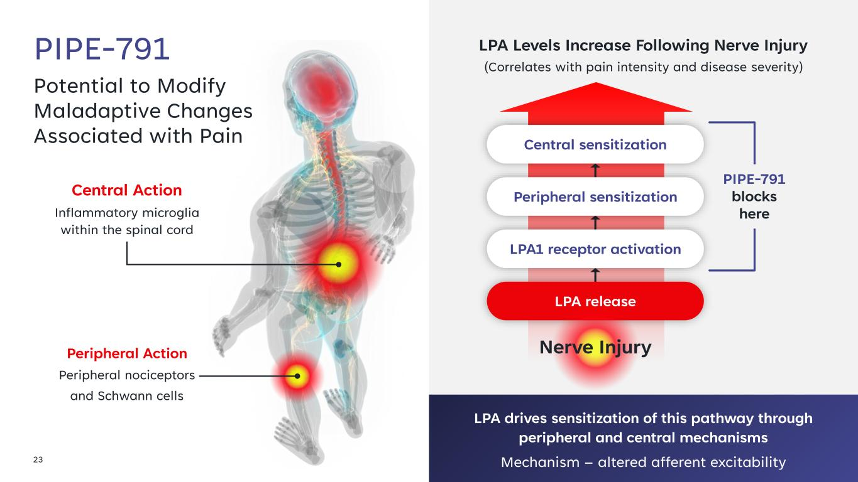
23 Potential to Modify Maladaptive Changes Associated with Pain PIPE-791 Central Action Inflammatory microglia within the spinal cord LPA drives sensitization of this pathway through peripheral and central mechanisms Mechanism – altered afferent excitability LPA Levels Increase Following Nerve Injury (Correlates with pain intensity and disease severity) Peripheral Action Peripheral nociceptors and Schwann cells PIPE-791 blocks here LPA release LPA1 receptor activation Peripheral sensitization Central sensitization Nerve Injury

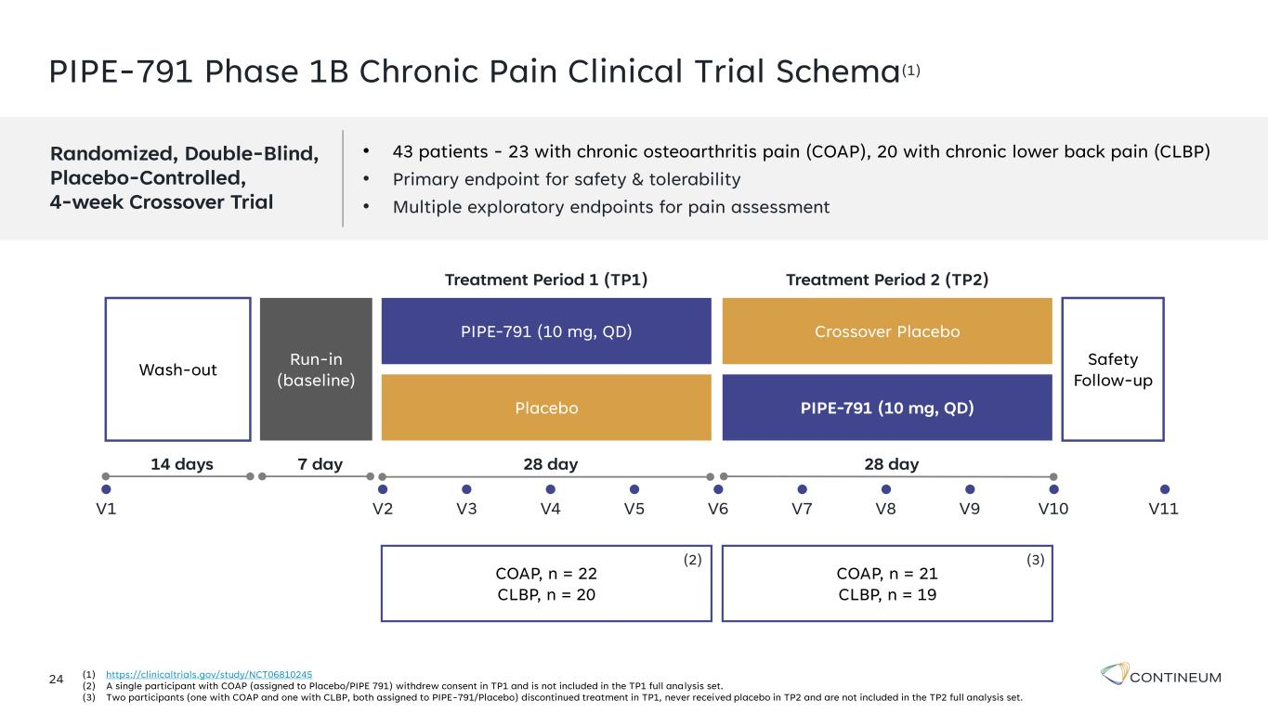
PIPE-791 Phase 1B Chronic Pain Clinical Trial Schema(1) • 43 patients - 23 with chronic osteoarthritis pain (COAP), 20 with chronic lower back pain (CLBP) • Primary endpoint for safety & tolerability • Multiple exploratory endpoints for pain assessment 24 (1) https://clinicaltrials.gov/study/NCT06810245 (2) A single participant with COAP (assigned to Placebo/PIPE 791) withdrew consent in TP1 and is not included in the TP1 full analysis set. (3) Two participants (one with COAP and one with CLBP, both assigned to PIPE-791/Placebo) discontinued treatment in TP1, never received placebo in TP2 and are not included in the TP2 full analysis set. Randomized, Double-Blind, Placebo-Controlled, 4-week Crossover Trial COAP, n = 22 CLBP, n = 20 COAP, n = 21 CLBP, n = 19 Wash-out Run-in (baseline) PIPE-791 (10 mg, QD) Crossover Placebo Placebo PIPE-791 (10 mg, QD) Treatment Period 1 (TP1) Treatment Period 2 (TP2) Safety Follow-up 14 days 7 day 28 day 28 day V1 V2 V3 V4 V5 V6 V7 V8 V9 V10 V11 (2) (3)

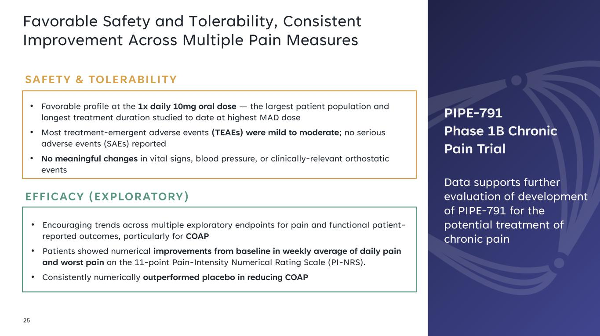
Favorable Safety and Tolerability, Consistent Improvement Across Multiple Pain Measures 25 • Favorable profile at the 1x daily 10mg oral dose — the largest patient population and longest treatment duration studied to date at highest MAD dose • Most treatment-emergent adverse events (TEAEs) were mild to moderate; no serious adverse events (SAEs) reported • No meaningful changes in vital signs, blood pressure, or clinically-relevant orthostatic events SAFETY & TOLERABILITY • Encouraging trends across multiple exploratory endpoints for pain and functional patient- reported outcomes, particularly for COAP • Patients showed numerical improvements from baseline in weekly average of daily pain and worst pain on the 11-point Pain-Intensity Numerical Rating Scale (PI-NRS). • Consistently numerically outperformed placebo in reducing COAP EFFICACY (EXPLORATORY) PIPE-791 Phase 1B Chronic Pain Trial Data supports further evaluation of development of PIPE-791 for the potential treatment of chronic pain

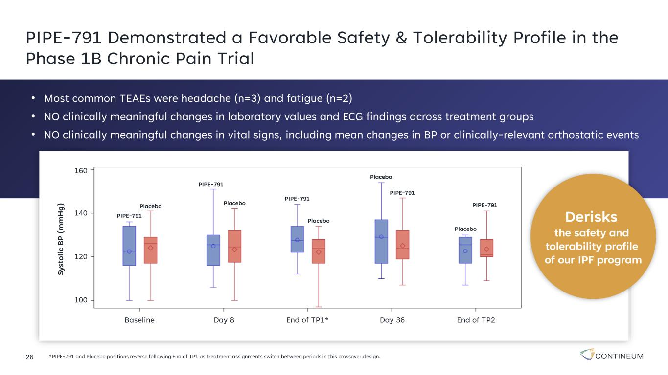
26 PIPE-791 Demonstrated a Favorable Safety & Tolerability Profile in the Phase 1B Chronic Pain Trial *PIPE-791 and Placebo positions reverse following End of TP1 as treatment assignments switch between periods in this crossover design. S y st o li c B P ( m m H g ) 160 140 120 100 Baseline Day 8 Day 36End of TP1* End of TP2 PIPE-791 Placebo PIPE-791 PIPE-791 PIPE-791 PIPE-791Placebo Placebo Placebo Placebo • Most common TEAEs were headache (n=3) and fatigue (n=2) • NO clinically meaningful changes in laboratory values and ECG findings across treatment groups • NO clinically meaningful changes in vital signs, including mean changes in BP or clinically-relevant orthostatic events Derisks the safety and tolerability profile of our IPF program

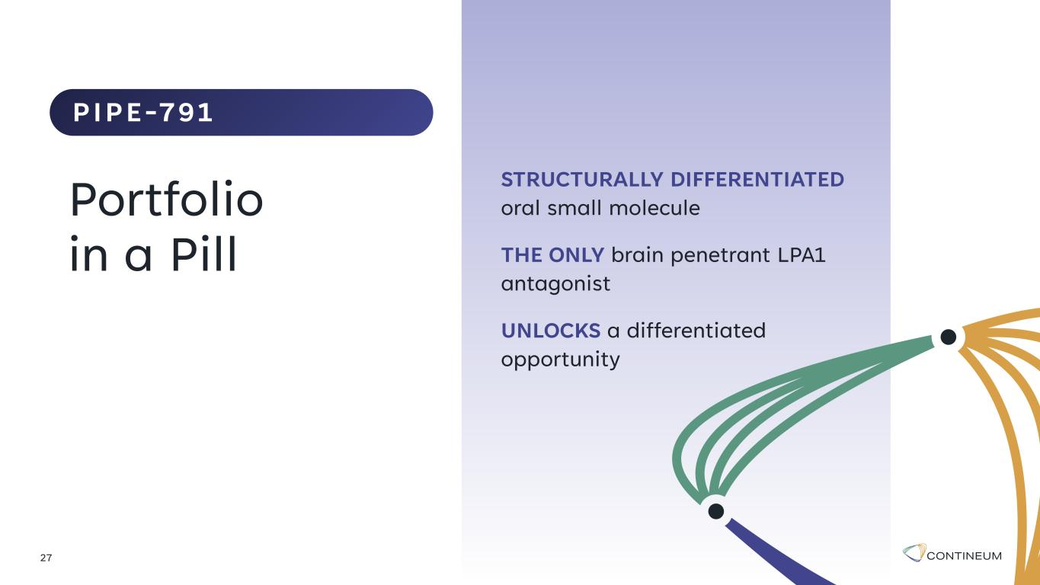
STRUCTURALLY DIFFERENTIATED oral small molecule THE ONLY brain penetrant LPA1 antagonist UNLOCKS a differentiated opportunity 27 Portfolio in a Pill PIPE-791

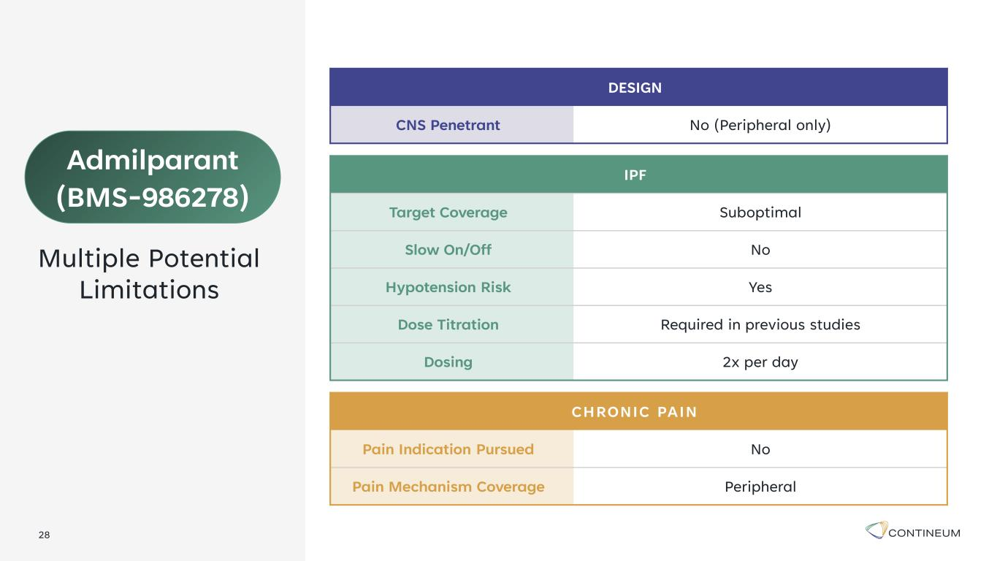
28 IPF Target Coverage Suboptimal Slow On/Off No Hypotension Risk Yes Dose Titration Required in previous studies Dosing 2x per day DESIGN CNS Penetrant No (Peripheral only) CHRONIC PAIN Pain Indication Pursued No Pain Mechanism Coverage Peripheral Admilparant (BMS-986278) Multiple Potential Limitations

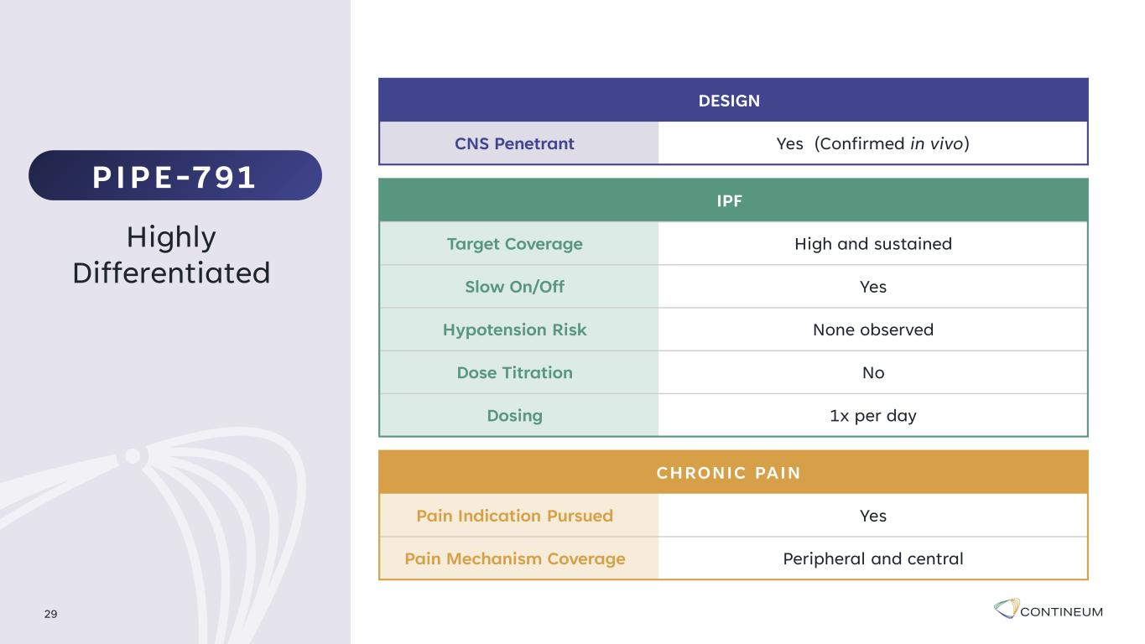
IPF Target Coverage High and sustained Slow On/Off Yes Hypotension Risk None observed Dose Titration No Dosing 1x per day 29 Highly Differentiated DESIGN CNS Penetrant Yes (Confirmed in vivo) CHRONIC PAIN Pain Indication Pursued Yes Pain Mechanism Coverage Peripheral and central PIPE-791

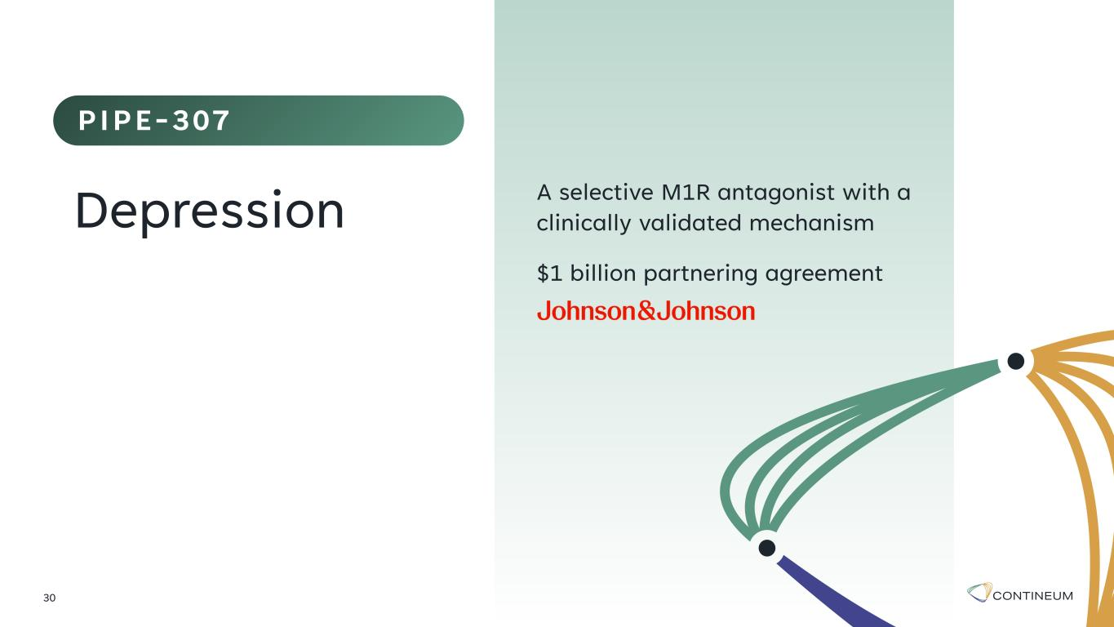
A selective M1R antagonist with a clinically validated mechanism $1 billion partnering agreement 30 Depression PIPE-307

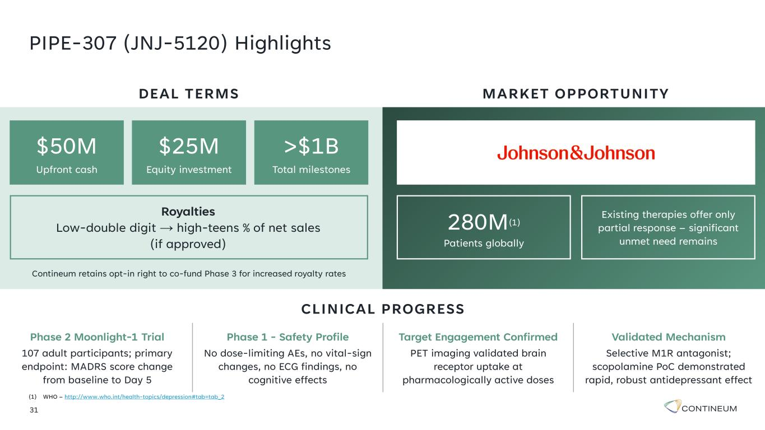
31 PIPE-307 (JNJ-5120) Highlights Phase 2 Moonlight-1 Trial 107 adult participants; primary endpoint: MADRS score change from baseline to Day 5 Phase 1 - Safety Profile No dose-limiting AEs, no vital-sign changes, no ECG findings, no cognitive effects Target Engagement Confirmed PET imaging validated brain receptor uptake at pharmacologically active doses Validated Mechanism Selective M1R antagonist; scopolamine PoC demonstrated rapid, robust antidepressant effect CLINICAL PROGRESS DEAL TERMS Royalties Low-double digit → high-teens % of net sales (if approved) Contineum retains opt-in right to co-fund Phase 3 for increased royalty rates MARKET OPPORTUNITY $50M Upfront cash $25M Equity investment >$1B Total milestones 280M(1) Patients globally Existing therapies offer only partial response – significant unmet need remains (1) WHO – http://www.who.int/health-topics/depression#tab=tab_2

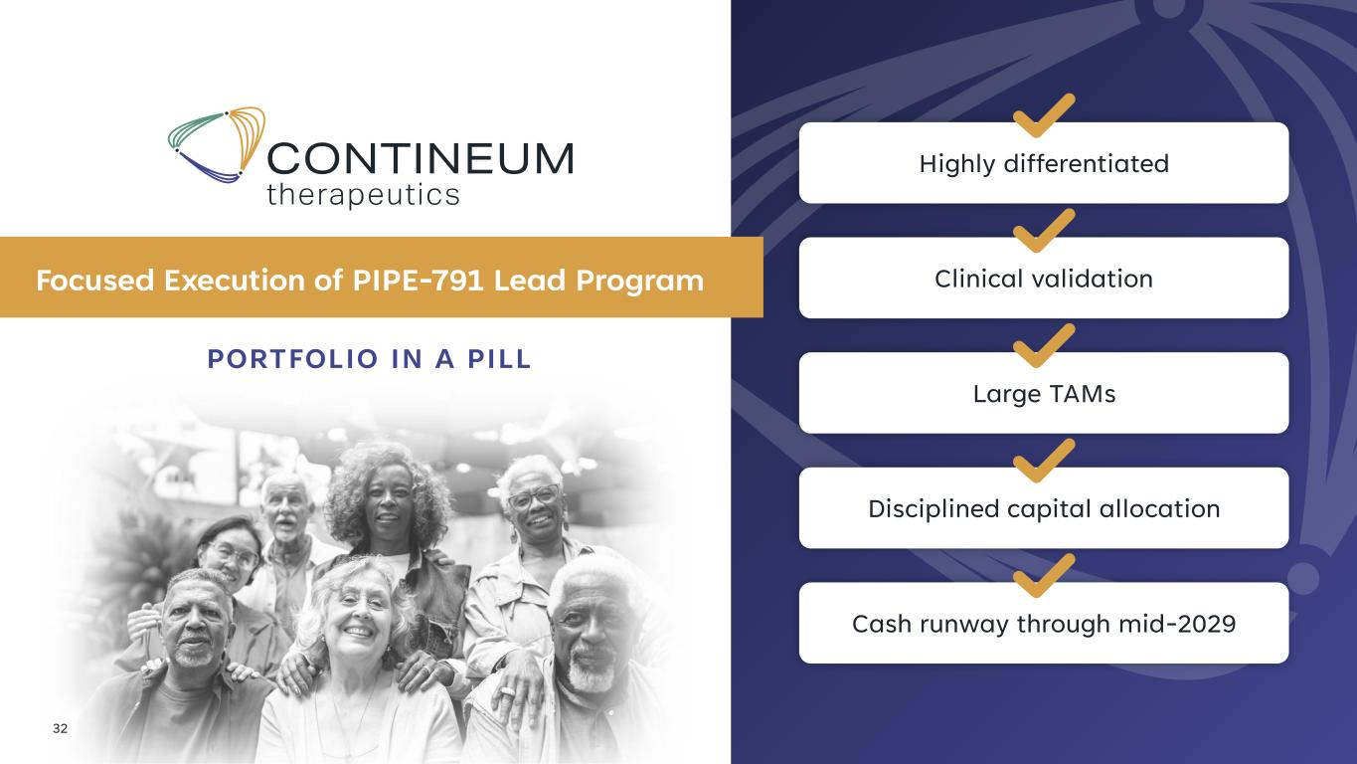
32 PORTFOLIO IN A PILL Focused Execution of PIPE-791 Lead Program Highly differentiated Clinical validation Large TAMs Disciplined capital allocation Cash runway through mid-2029

